### Use Case 3：User Location

|  |  |
| --- | --- |
| User case | User Location |
| Related Requirem’ts | Open Mobile GPS Access |
| Initiating Actor | user |
| Actor’s Goal | Open position, automatic positioning |
| Participating Actors | Smart phones, hands,GPS |
| Preconditions | Have the location and storage rights of mobile phones. Open APP |
| Postconditions | Open GPS |
| Flow of Events for Main Success Scenario | 1.Open APP at the current location 2.Enter the search button 3.Display the current location |

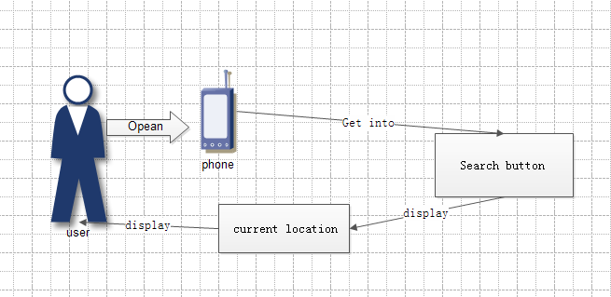

Use Case 4：User Location

|  |  |
| --- | --- |
| User case | Route planning and feedback to users |
| Related Requirem’ts | Open the mobile phone GPS access. |
| Initiating Actor | user |
| Actor’s Goal | Open position, automatic positioning |
| Participating Actors | Smartphones, Hands, GPS |
| Preconditions | Have the location and storage rights of mobile phones. Open APP. |
| Postconditions | Running Settable Preferences Algorithms. |
| Flow of Events for Main Success Scenario | 1. Open APP at the current location 2. Enter the search button 3. Display the current location 4. Input destination 5. Choosing Personal Preferences 6. Display personal paths |

